Part 1: Theory

1. What is a Power Supply System?
A Power Supply System provides electrical power to a computer and its components.
Electricity from the wall socket cannot be used directly by computer components because:
- Wall power is AC (Alternating Current).
- Computer components need DC (Direct Current).
Therefore, a device is needed to convert AC to DC.
This device is called an SMPS.

2. What is SMPS?
SMPS = Switched Mode Power Supply
It is a hardware component inside the computer cabinet that converts AC power into different DC voltages required by computer components.

Functions of SMPS
- Converts AC to DC.
- Supplies power to motherboard.
- Supplies power to CPU.
- Supplies power to hard disk/SSD.
- Supplies power to graphics card.
- Protects components from voltage fluctuations.

Common Output Voltages
Voltage | Usage
+12V | CPU, Fans, Graphics Card
+5V | USB Devices, Hard Disk
+3.3V | RAM, Motherboard Components

Real-Life Example
Think of SMPS as a translator.
Wall Socket → AC Power
Computer Components → Need DC Power
SMPS translates AC into DC so components can understand and use it.

3. Parts of an SMPS
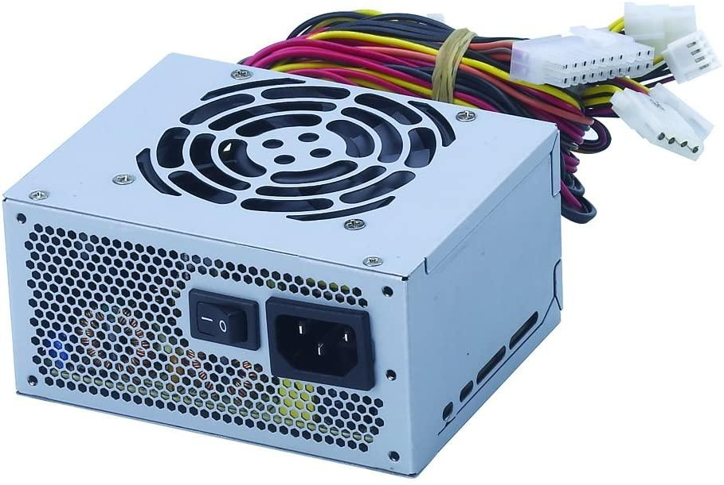
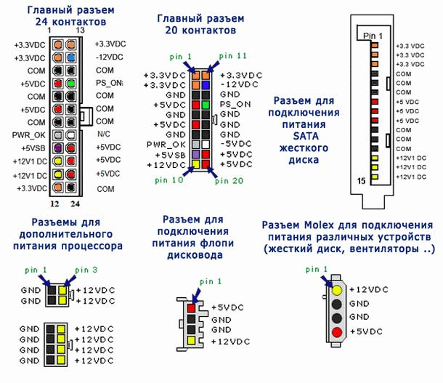
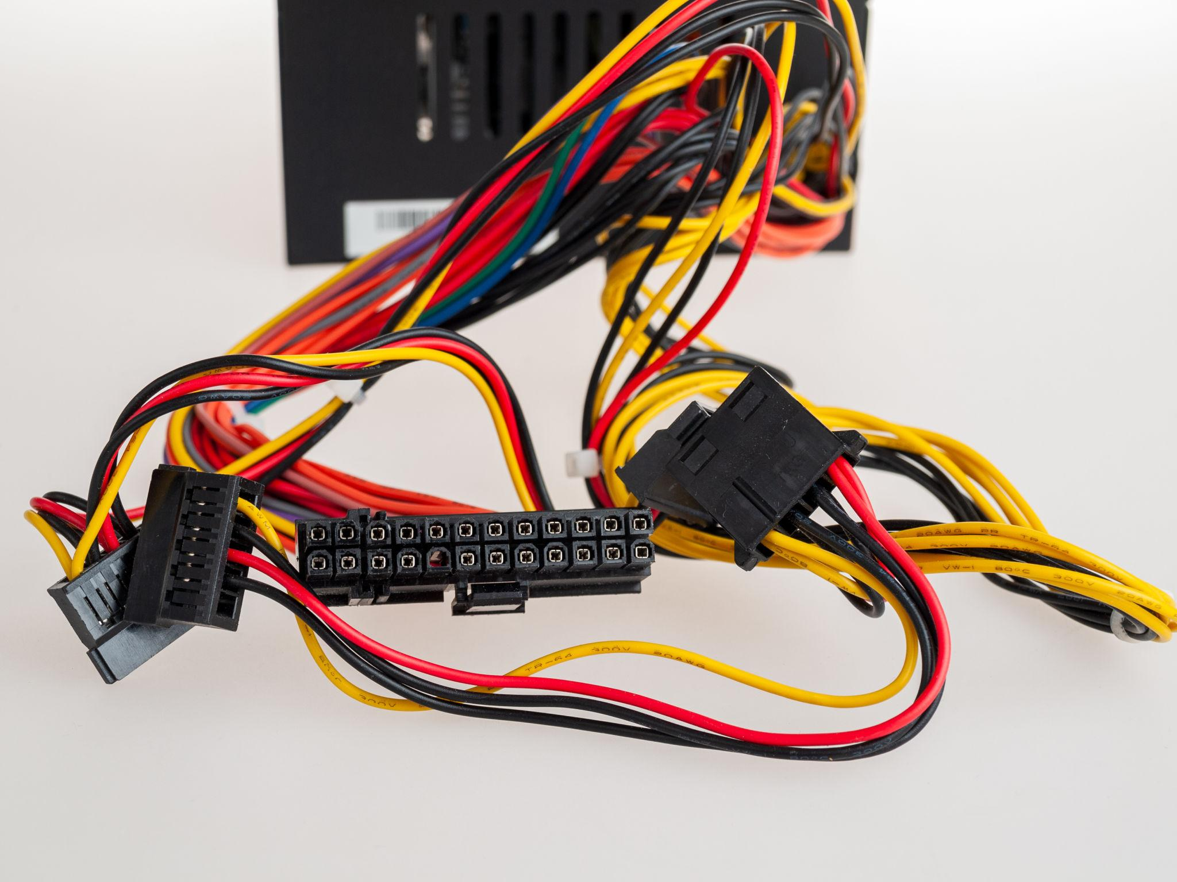
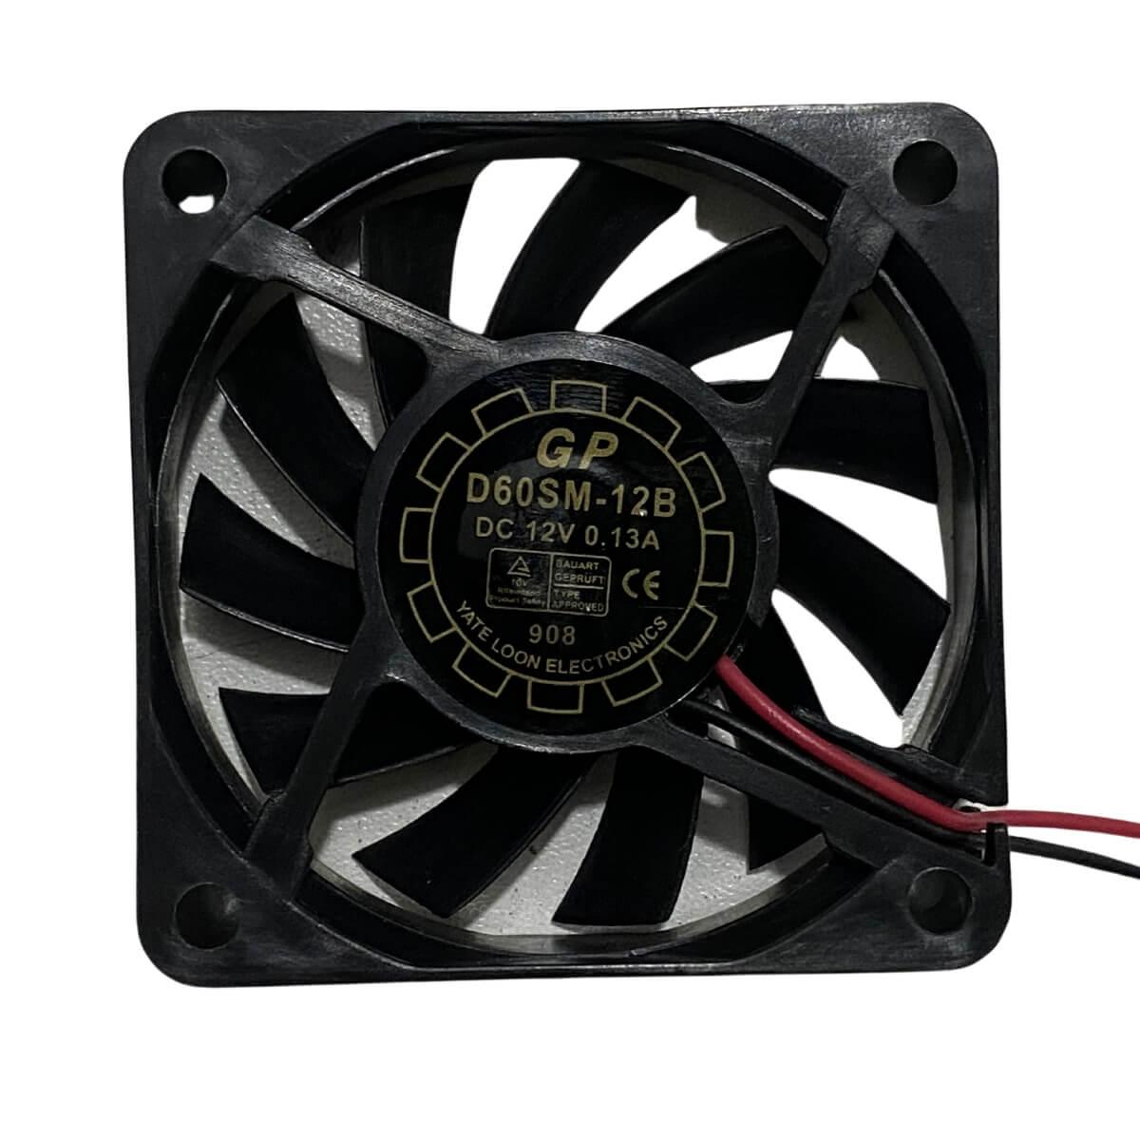

Main Parts
- Cooling Fan
  - Prevents overheating.
- Power Switch
  - Turns power supply ON/OFF.
- Power Socket
  - Connects AC cable.
- Output Connectors
  - Connect motherboard and storage devices.

4. Advantages of SMPS
- High efficiency
- Less heat generation
- Compact size
- Lightweight
- Reliable operation

5. What is UPS?
UPS = Uninterruptible Power Supply
A UPS provides backup power when electricity fails.

Functions of UPS
- Provides temporary backup power.
- Protects against power cuts.
- Protects against voltage fluctuations.
- Allows safe shutdown of computer.

Real-Life Example
Imagine you are saving an important project.
Suddenly electricity goes off.
Without UPS:
- Computer shuts down immediately.
- Unsaved work may be lost.
With UPS:
- Computer continues running for a few minutes.
- You can save your work safely.

6. Types of UPS

1. Offline UPS
- Most common.
- Used in homes and small offices.

2. Online UPS
- Provides continuous power.
- Used in servers and data centers.

3. Line Interactive UPS
- Better voltage regulation.
- Used in offices.

7. SMPS vs UPS
Feature | SMPS | UPS
Full Form | Switched Mode Power Supply | Uninterruptible Power Supply
Purpose | Converts AC to DC | Provides Backup Power
Installed | Inside Computer | Outside Computer
Backup Battery | No | Yes
Protects From | Voltage Issues | Power Failure

Part 2: Practical

Practical 1: Identify Power Cables
Ask students to identify the following cables.
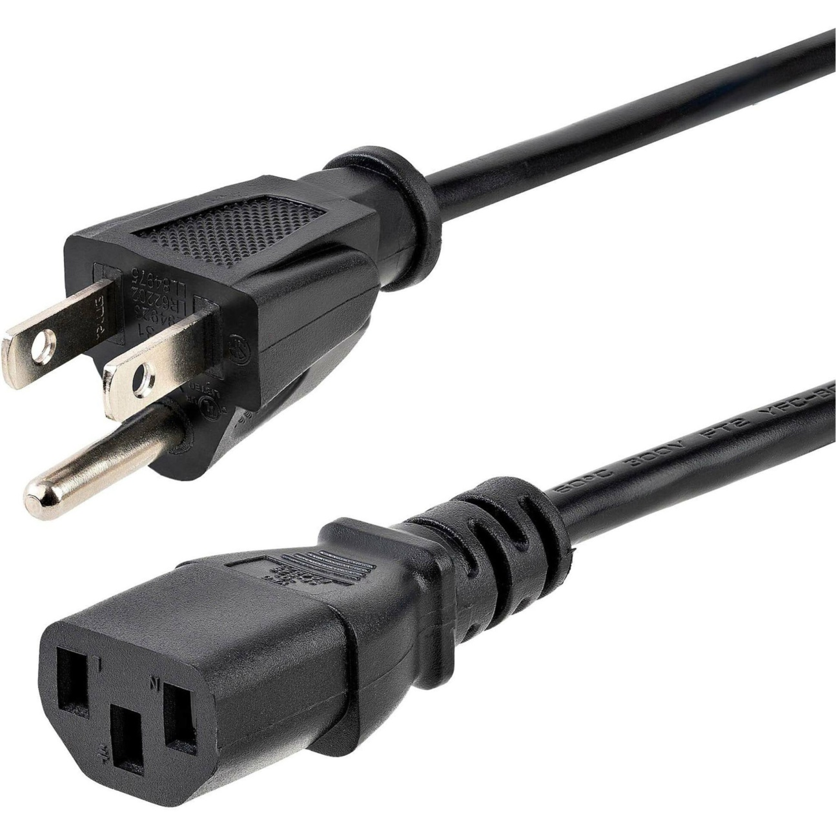
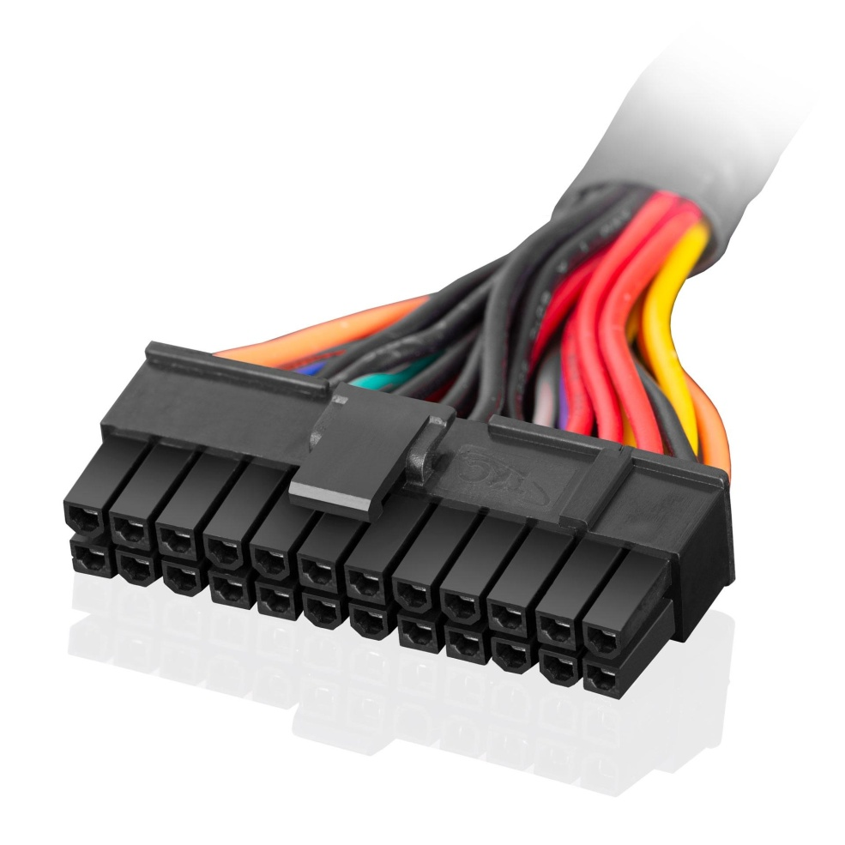
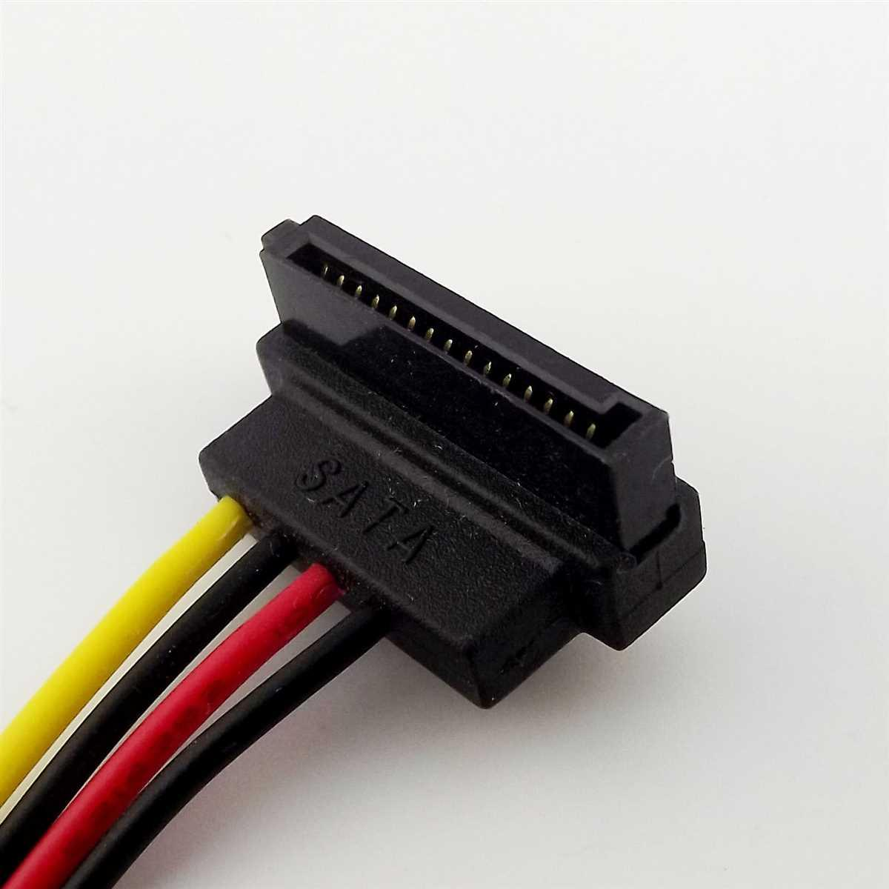
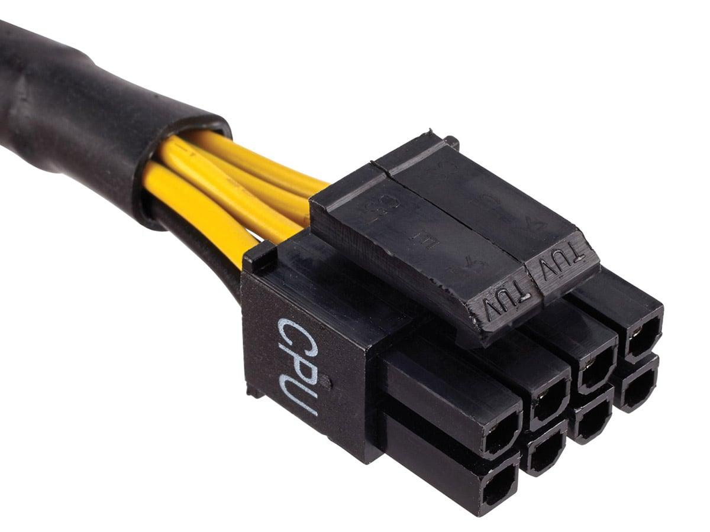
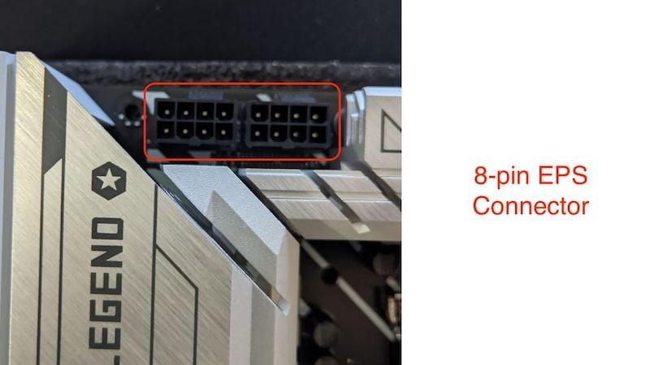

A. AC Power Cable
Used to connect:
- UPS to Wall Socket
- Computer to UPS
Identification:
- Thick cable
- Three-pin connector

B. 24-Pin ATX Connector
Used to provide power to:
- Motherboard
Identification:
- Largest connector from SMPS.

C. SATA Power Connector
Used for:
- SSD
- HDD
- DVD Drive
Identification:
- Flat black connector.

D. CPU Power Connector (4/8 Pin)
Used to power:
- Processor
Connected near CPU socket on motherboard.

Practical 2: Locate Power Components
Students should open a CPU cabinet and identify:
✓ SMPS
✓ Motherboard Power Connector
✓ CPU Power Connector
✓ SATA Power Connector
✓ Cooling Fan
✓ Power Switch

Practical 3: Check UPS Backup

Steps
- Turn ON computer.
- Connect through UPS.
- Remove UPS input power.
- Observe system remains ON.
Discussion:
- How long does UPS provide backup?
- Why is UPS important?

Practical 4: Check Battery Status Using CMD
Open Command Prompt:
powercfg /batteryreport
Generates battery report (for laptops).
Report location:
C:\Users\Username\battery-report.html
Students can open the report in browser.

Practical 5: View Power Configuration
powercfg /a
Shows available sleep and power states.

Practical 6: See System Uptime
systeminfo | find "Boot Time"
OR
net statistics workstation
Shows when the system was last started.

Practical 7: Shutdown Timer
shutdown /s /t 60
Computer will shut down after 60 seconds.
Cancel shutdown:
shutdown /a
Students usually find this practical interesting.

Practical 8: Restart Computer After 30 Seconds
shutdown /r /t 30
Explanation:
- /r = Restart
- /t = Time in seconds
Cancel:
shutdown /a

Find Biggest Files on PC
File Explorer Search:
size:>100MB
OR
size:>1GB
Students can identify storage-hungry files.

View Hidden Files
File Explorer → View → Hidden Items
Show:
- AppData folder
- Hidden system files
Explain why malware often hides here.

Open Notepad.
Type:
.LOG
Save file.
Close and reopen it.

Personal Message Box
Create a file:
message.vbs
Paste:
MsgBox "Welcome to Today's Practical Session!"
Save and double-click.
A popup message appears.
Students can customize their own messages.

Make the Computer Speak
Create:
speak.vbs
Paste:
Set speech=CreateObject("sapi.spvoice")
speech.Speak "Hello Students, Welcome to Computer Lab"
Save and run.
Computer will speak the message.

Generate Random Numbers
CMD:
echo %random%
Run multiple times.
Create a simple guessing game.
Example:
echo Guess number between 1 and 100
echo Actual Number = %random%

Digital Clock in CMD
Create:
@echo off
:time
cls
echo %time%
timeout /t 1 >nul
goto time

Find All IP Addresses in Network
CMD:
arp -a
Shows devices recently connected on the network.
Students get excited seeing multiple IP addresses.

Funny Folder Names
Create folders named:
Homework
Exams
Secret Files
Then use:
attrib +h Homework
Folder disappears.
Show hidden items to bring it back.
Useful introduction to file attributes.

Folder Attributes Practical (Windows CMD)

Step 1: Create Folders
Open Command Prompt (CMD) and run:
mkdir Homework
mkdir Exams
mkdir "Secret Files"
Or create all folders at once:
mkdir Homework Exams "Secret Files"

Step 2: Hide the Homework Folder
attrib +h Homework
+h = Hidden Attribute
The Homework folder will no longer be visible in File Explorer.

Step 3: Show Hidden Items
- Open File Explorer.
- Click on the View menu.
- Select Show → Hidden Items.
The Homework folder will become visible again.

Step 4: Unhide the Folder
Run the following command in CMD:
attrib -h Homework
-h = Remove Hidden Attribute

Extra Practical Activity
Make the folder Hidden + System:
attrib +h +s Homework
Now the folder may remain hidden even when Hidden Items is enabled.
To restore it:
attrib -h -s Homework

Check Folder Attributes
attrib Homework
Example Output:
SH Homework

Attribute Meanings
Attribute | Meaning
S | System
H | Hidden
R | Read Only
A | Archive

Create Password Protected ZIP
Right-click folder → Send To → Compressed Folder.
Then use WinRAR/7-Zip to add password.
Teach basic file security.
Encrypt Drive
Encrypt pendrive
Encrypt document

Practical: Password Protect a Microsoft Word Document

Steps
- Open Microsoft Word.
- Create a new document and add some text.
- Click File (or Office Button in Word 2007).
- Select Info.
- Click Protect Document.
- Choose Encrypt with Password.
- Enter a password.
- Re-enter the password to confirm.
- Save the document.

Test
- Close the document.
- Open it again.
- Word will ask for the password before opening the file.

Remove Password
- Open the document using the password.
- Go to File → Info → Protect Document → Encrypt with Password.
- Delete the existing password.
- Click OK and save the file.

Practical: Password Protect a Microsoft Excel Workbook

Steps
- Open Microsoft Excel.
- Create a workbook and enter some data.
- Click File.
- Select Info.
- Click Protect Workbook.
- Choose Encrypt with Password.
- Enter a password.
- Re-enter the password to confirm.
- Save the workbook.

Test
- Close the workbook.
- Open it again.
- Excel will ask for the password before opening the file.

Remove Password
- Open the workbook using the password.
- Go to File → Info → Protect Workbook → Encrypt with Password.
- Remove the existing password.
- Click OK and save the workbook.

Extra Questions
- What is the full form of SMPS?
- Why is SMPS required in a computer?
- What is the full form of UPS?
- What is the purpose of UPS?
- What is the difference between AC and DC?
- Which connector powers the motherboard?
- Which connector powers the CPU?
- What is the use of a SATA power connector?
- What happens if there is no UPS during a power failure?
- Which command shows battery information in Windows?

Conclusion
- SMPS converts AC power into usable DC power for computer components.
- UPS provides backup power during electricity failures.
- Students should be able to identify major power cables and connectors and understand their functions.

